PCHS AP Human Geography Name: ________________________________________

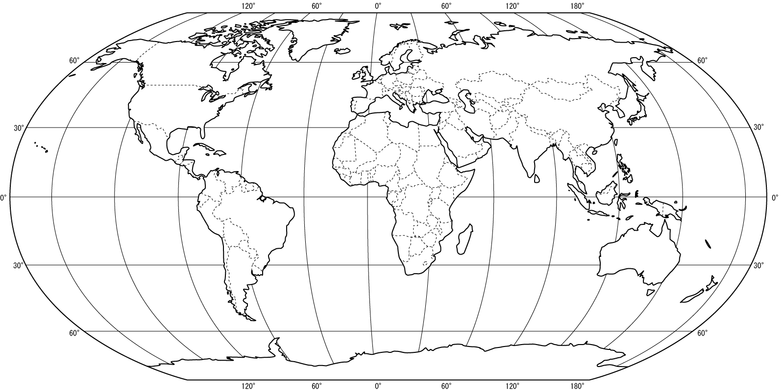
Endangered Languages

Directions: Use Source 1 (endangeredlanguages.com) to complete the first 3 rows of the chart. Plot the location of each language on the map above. Find the link to Source 1 on our class Weebly page.

Map Key | Language Name | Language Family | Why is it endangered?  - Demographics / numbers of native speakers?  Describe any preservation efforts.  - What is being done to keep this language alive?
Choose ONE of the following Celtic Languages: Welsh, Irish, Scottish, Cornish, Breton
United Kingdom, Ireland, France

Maori
New Zealand

Languedocian (Occitan)
France

Directions: Use Source 1 (endangeredlanguages.com) OR Source 2 (storymaps.esri.endangered-languages.com) to complete the chart with languages of your choice.

Add the location of each language to the map. Find the links to Source 1 and Source 2 on our class Weebly page.

Map Key | Language Name | Language Family | Why is it endangered?  - Demographics / numbers of native speakers?  Describe any preservation efforts.  - What is being done to keep this language alive?

Directions: The following languages are isolated, but not endangered. Add them to the map and research why they are not endangered, even though very few people speak them.

- Basque -

- Icelandic -

How should the Hebrew language be classified (at risk of endangered, endangered, isolated)? Where is it spoken?

Extra Time? Search the web. List 3 arguments in support of the preservation of endangered languages. Do you agree? Explain.

